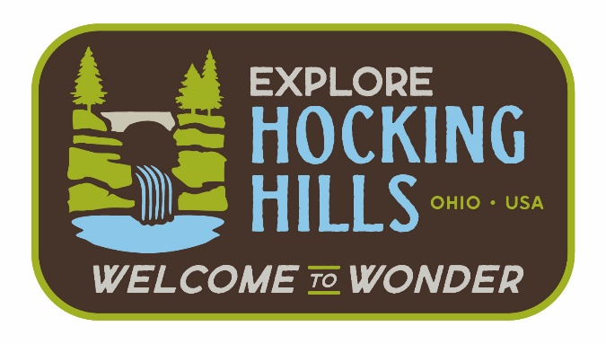

Tourism Impact Emergency Services Grant Program Vision and Mission

Vision Statement
Tourism Impact Emergency Services Grant – Hocking County, Ohio
To ensure that Hocking County remains a safe and welcoming destination by equipping our emergency services with the tools, training, and support needed to respond effectively to the unique demands of a thriving tourism economy, protecting both residents and the millions who visit our forests, trails, and communities each year.

Mission Statement
Tourism Impact Emergency Services Grant – Hocking County, Ohio
The mission of the Tourism Impact Emergency Services Grant is to enhance Hocking County’s local emergency response agencies that are impacted by tourism-related activity, ensuring safe experiences for both residents and guests across our region.

