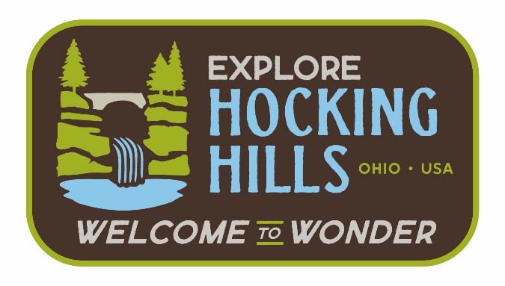

**Tourism Impact Emergency Services Grant Program Vision and Mission**

**Vision Statement**

**Tourism Impact Emergency Services Grant – Hocking County, Ohio**

*To ensure that Hocking County remains a safe and welcoming destination by equipping our emergency services with the tools, training, and support needed to respond effectively to the unique demands of a thriving tourism economy—protecting both residents and the millions who visit our forests, trails, and communities each year.*

**Mission Statement**

**Tourism Impact Emergency Services Grant – Hocking County, Ohio**

*The mission of the Tourism Impact Emergency Services Grant is to enhance public safety in Hocking County by funding local emergency response agencies that are impacted by tourism-related activity, ensuring safe experiences for both residents and guests across our region.*